*FeyNN Labs: Project 2*

*Link:* [Github](https://github.com/Durgaprasad53/Market-Segmentation-of-Electric-Vehicles-in-India/blob/main/3_ev_market_india_dataset.xlsx)

# Market Segmentation Analysis of Electric Vehicles Market in India

Contributors

Indanam DurgaPrasad

## Date: 16th March, 2025

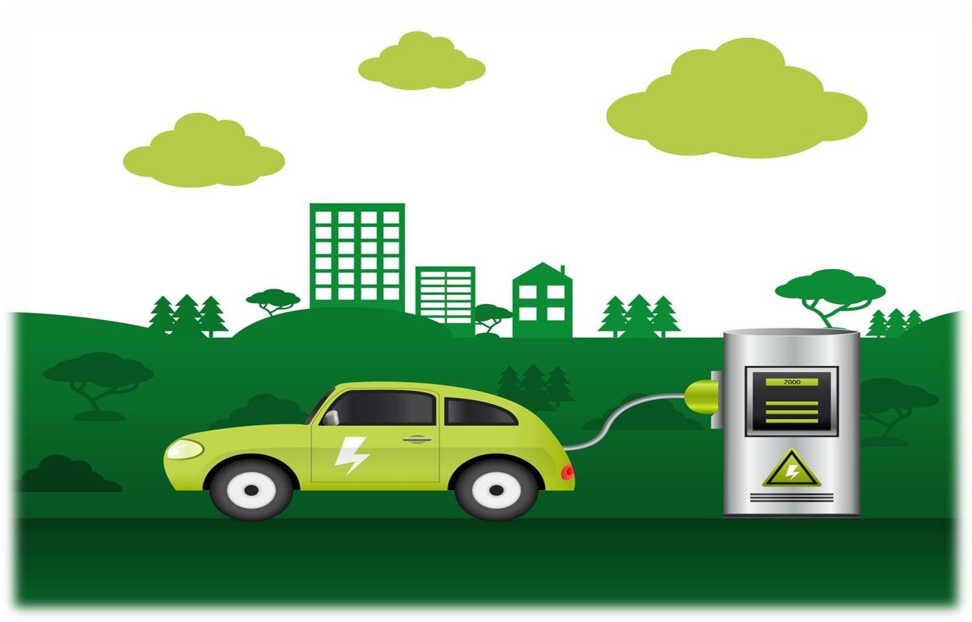

## Problem Statement

Task is to analyze the Electric Vehicles Market in India using *Segmentation* analysis and come up with a feasible strategy to enter the market, targeting the segments most likely to use their product in terms of Geographic, Demographic, Psychographic, and Behavioral.

In this report we analyze the Electric Vehicles Market in India using segments such as region, price, charging facility, type of vehicles (e.g., 2 wheelers, 3 wheelers, 4 wheelers etc.), retail outlets, manufacturers, body type (e.g., Hatchback, Sedan, SUV, Autorickshaw etc.), safety, plug types and much more.

## Fermi Estimation

Wild Guess: Around 8-10% people will have electric vehicles by the end of 2023 in India. Educated Guess:

Employment rate = it is the ratio of number of available labor force to the population of People in the working age.

We think there are about 1.5 billion Indians in the world. Let's assume the only people over18 and under 60 works, assuming that they account for around 60% of the population then that would make 0.9 billion Indians in the working class. Out of the 0.9 billion people not all are employed, assuming only 2023 had 45% employment rate that would bring the number around 405 million.

Since, not everyone can afford an electric vehicle, let’s assume only people above middle class can afford an electric vehicle, that would be 40 million. Not everyone buysan electric vehicle. Let’s assume out of these 40 million only 10 million are willing to buy an electric vehicle.

Variables and Formulas:

Let E(x) be the employment rate of the year x (in %). Let P(x) be the population of the year x.

Let A(x) be the number of available Labor in the year x.

Let r be the ratio of Indians between the age of 18 and 60 to the total population of India.

E(x) = (A(x)*100)/(P(x)*r)

This formula will formulate the Employment ratio for the year x.

Gathering More Information:

Estimation for the population of the year 2022 can be obtained by the increase in population each year

P (2019) = 1.3676 billion

P (2020) = 1.3786 billion

P (2021) = 1.39199 billion

P (2020)-P (2019) = 11million P (2021)-P (2020) = 13.39 million the mean would be 12.195 million

thus P (2022) = 1.44185 billion assuming A(x) is constant every year= 471,688,990r=0.6 C=0.75

E (2022) = (471,688,990/(1,441,850,000*0.6))*0.75 E (2022) = 42%

Conclusion: By this analysis, we conclude that by the end of the year 2024 there would a Employment rate of 42%. That would make 42% of 405 million i.e., 170 million. Out of these 170 million only 10% afford EV'S. So around 17 million people will have EV's by the end of 2024"

## Data Collection

Data was extracted from the various websites mentioned below for EV market segmentation.

Link for data extraction:

* <https://pib.gov.in/PressReleasePage.aspx?PRID=1842704> [https://www.ibef.org/blogs/electricvehicles-market-in-india](https://www.ibef.org/blogs/electric-vehicles-market-in-india)<https://evreporter.com/indias-region-wise-ev-market-jan-may-2022/>
* [https://www.india-briefing.com/news/indias-ev-manufacturing-capacity-and-marketpreferences- progress-25840.html/](https://www.india-briefing.com/news/indias-ev-manufacturing-capacity-and-market-preferences-progress-25840.html/)

Data from those links are extracted by Google play scraper available on libraries package. There are multiple datasets get extracted from those websites in CSV and Excel formats. There are some pdfs also which contains valuable information regarding the EV market. We have extracted data from those pdfs as well.

Raw data generated:

* <https://github.com/Durgaprasad53/Market-Segmentation-of-Electric-Vehicles-in-India/blob/main/1_ev_charger_dataset.csv>
* <https://github.com/Durgaprasad53/Market-Segmentation-of-Electric-Vehicles-in-India/blob/main/2_ev_charging_station_dataset.xlsx>
* <https://github.com/Durgaprasad53/Market-Segmentation-of-Electric-Vehicles-in-India/blob/main/3_ev_market_india_dataset.xlsx>

Columns explanations:

1. ‘Brand’ and tells the manufacturers of electric vehicles.
2. ‘model’ tells the various of electric vehicles.
3. ‘AccelSec’, ‘Top Speed’, ’Power Train’ tells specification about the vehicles.
4. ‘Range_km’, ‘Fast_Charge’, ‘Plug_type’ and **‘** Bodystyle’ tells us about range of vehicle per full charge,fast charging is provided or not, type of charging plug and body style of vehicle respectively.
5. ‘Seats’ and ‘Price’ tells about the number of seats available on vehicle and their price.
6. ‘Region’ and ‘State/UT’ tells about the states of India.
7. ‘EV Charging Facility’ and ‘Chargers’ tells about the facility of charging in the respective states.
8. ‘2V’, ‘3V’, ‘4V’, ‘Bus’ tells about the type of vehicles in the market.

## Data Preprocessing

Steps taken to preprocess the scraped raw data:

1. Ordinal encoded 'PowerTrain'
2. Label encoded 'RapidCharge’
3. Used Label Encoder and Standard Scaler package for preprocessing of the dataset.

## Exploratory Data Analysis

An Exploratory Data Analysis or EDA is a thorough examination meant to uncover the underlying structure of a data set and is important for a company because it exposes trends, patterns, and relationships that are not readily apparent.

We analyzed our dataset using *univariate* (analyze data over a single variable/column from a dataset), *bivariate* (analyze data by taking two variables/columns into consideration from a dataset) and *multivariate* (analyze data by taking more than two variables/columns into consideration from a dataset) analysis.

The bar graph below shows the diversity of the data geographically. We can see that we have the maximum amount of data of states *Karnataka* and *Maharashtra*; and minimum amount of data for *Sikkim, Meghalaya, Lakshadweep, Ladakh,* and *Dadra and Nagar Haveli and Daman and Diu*. There are a total of 1536 rows of data distributed among the cities shown in the graph.

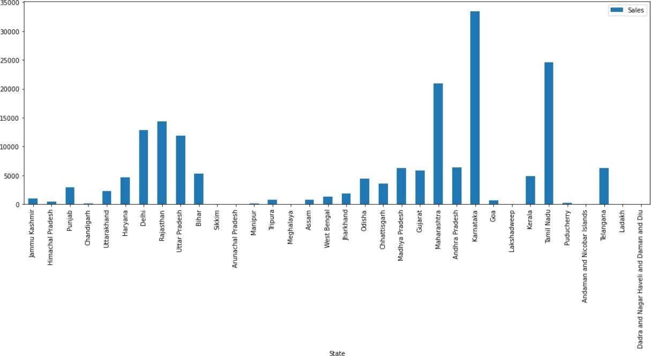

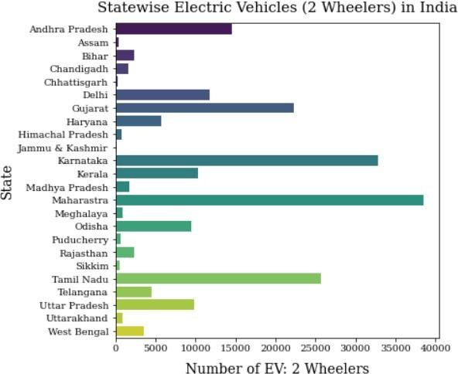

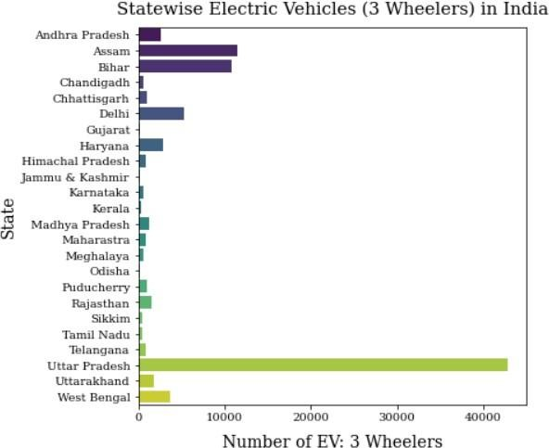

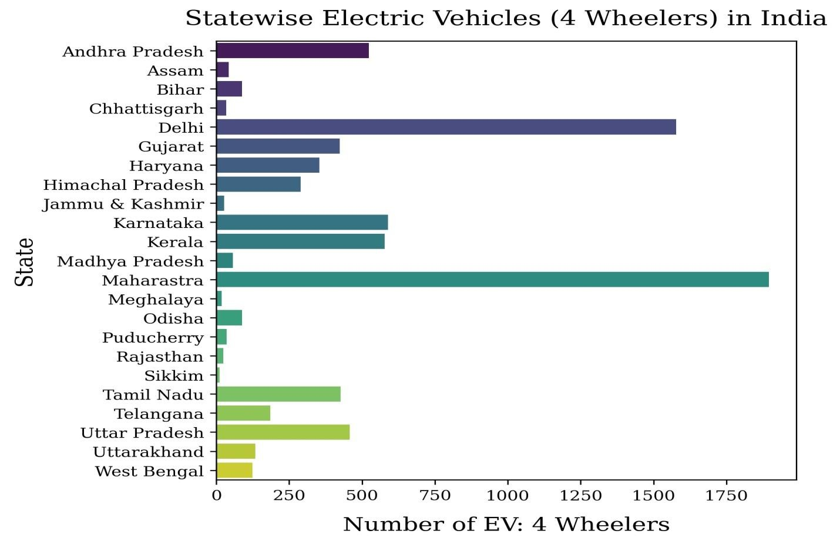

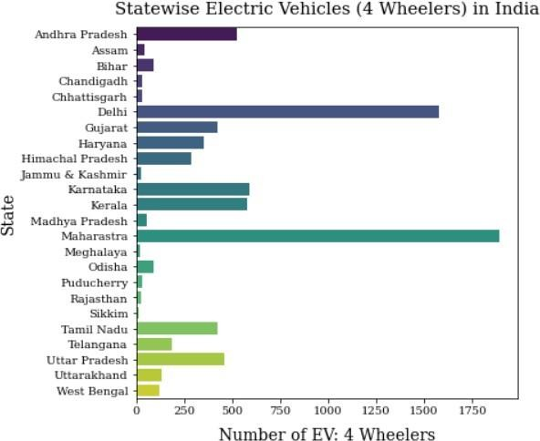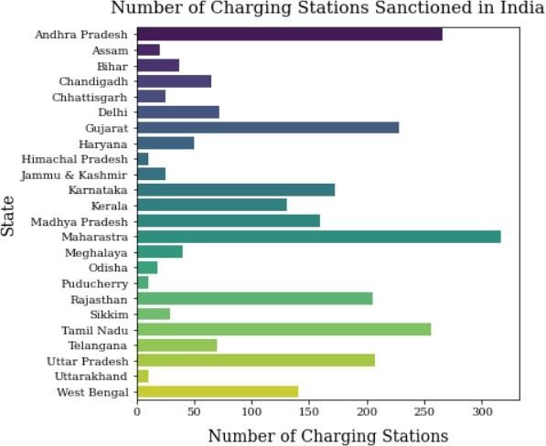

This Bar Chart shows the type of vehicles used in various states from the dataset after removing meaningless outliers. It also shows the Number of Charging Stations sanctioned in India state wise. Quick look at the graphs tells us that *Maharashtra, Karnataka, Andhra Pradesh, Tamilnadu* and *Gujrat* have the most number of electric vehicles and least number of electric vehicles are from *Sikkim, Meghalaya, Lakshadweep, Ladakh,* and *Assam* states.

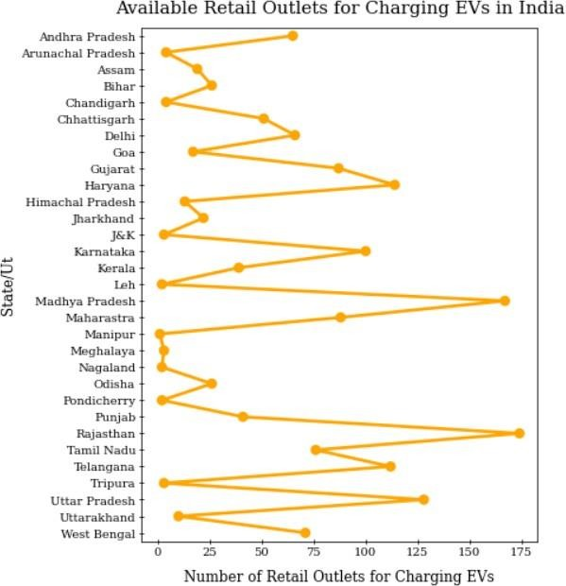

This point plot shows the number of retail outlets for charging EVs in various states from the dataset. Graphs shows us that *Maharashtra, Karnataka, Andhra Pradesh, Tamilnadu* and *Gujrat* have the most number of retail outlets for charging EVs and least number of retail outlets for charging EVs are from *Sikkim, Meghalaya, Lakshadweep, Ladakh,* and *Assam* states*.*

This bar graphs shows the manufacturers of Electric Vehicles.

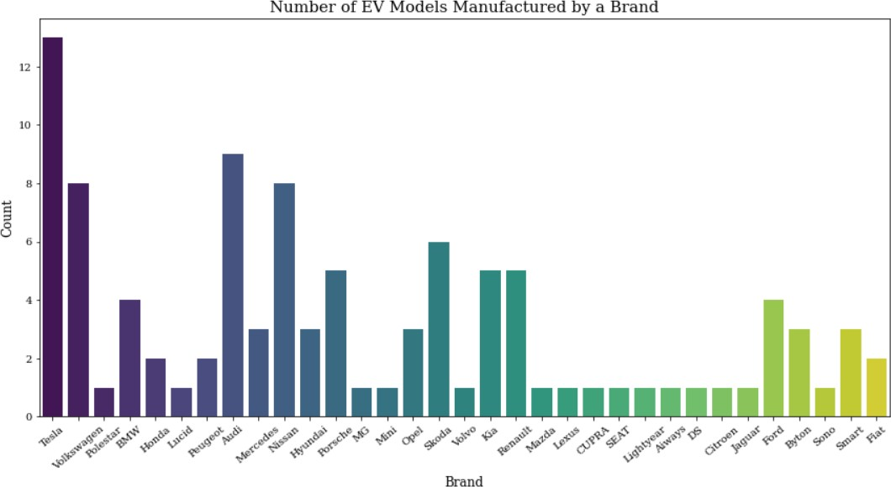

This pie chart shows the different types of Electric Vehicles.

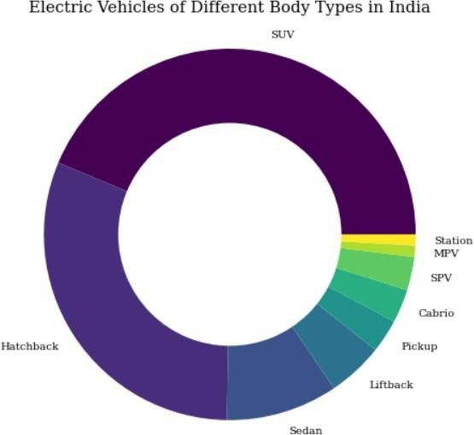

This bar graph shows the number of seats available in Electric Vehicles.

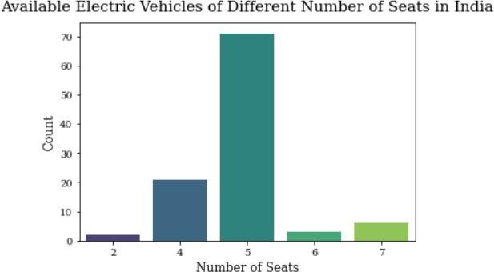

This bar graph shows the number of seats available in Electric Vehicles available in India.

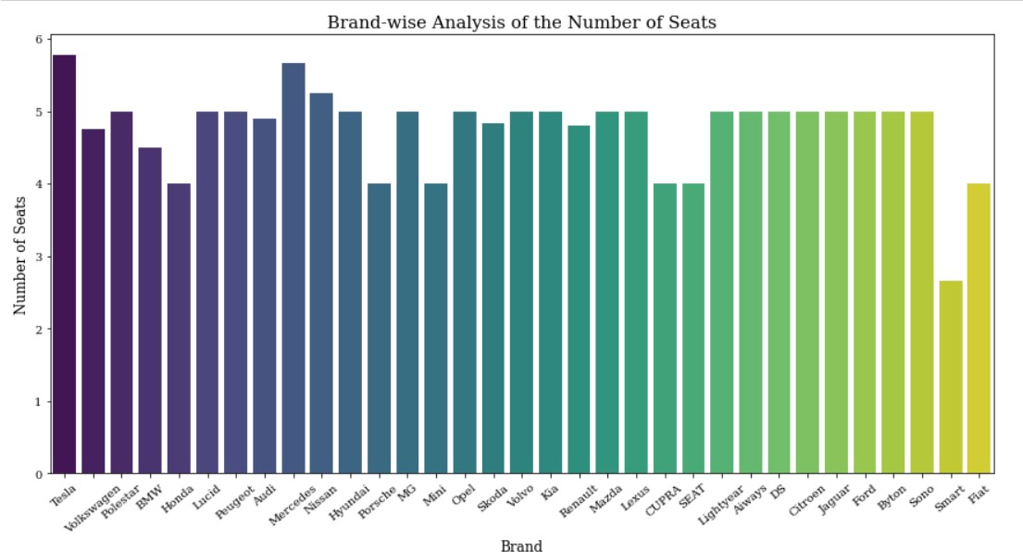

This bar graph shows the available plug types in Electric Vehicles.

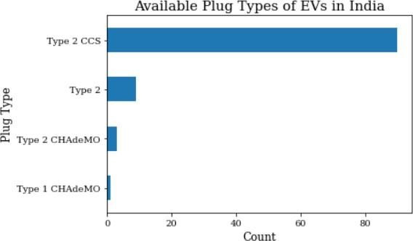

This line graph shows the price comparisons in Electric Vehicles.

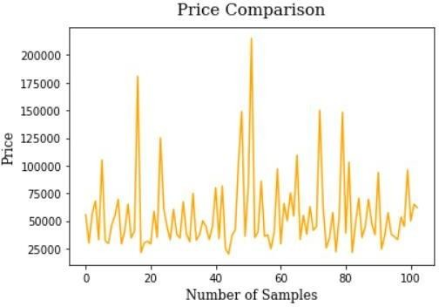

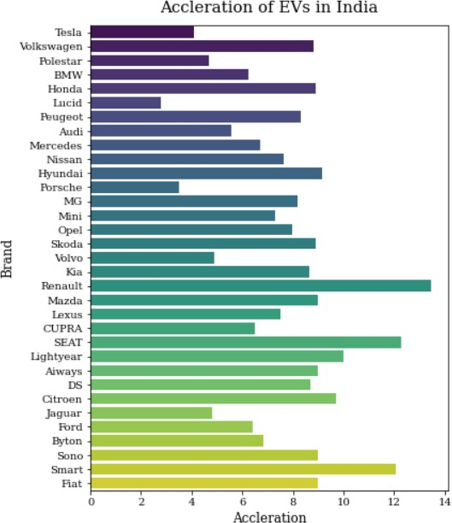

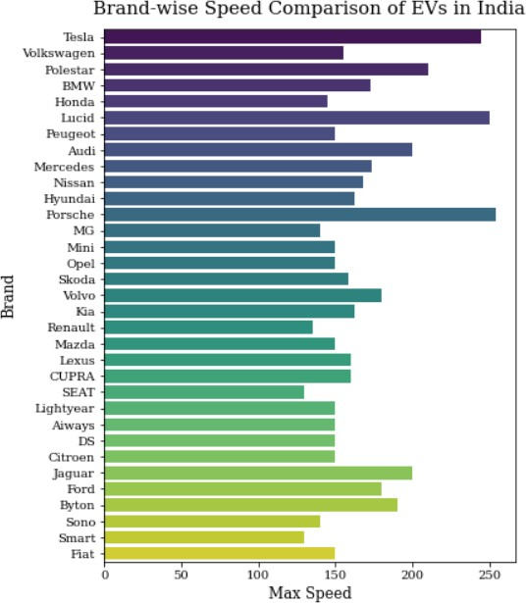

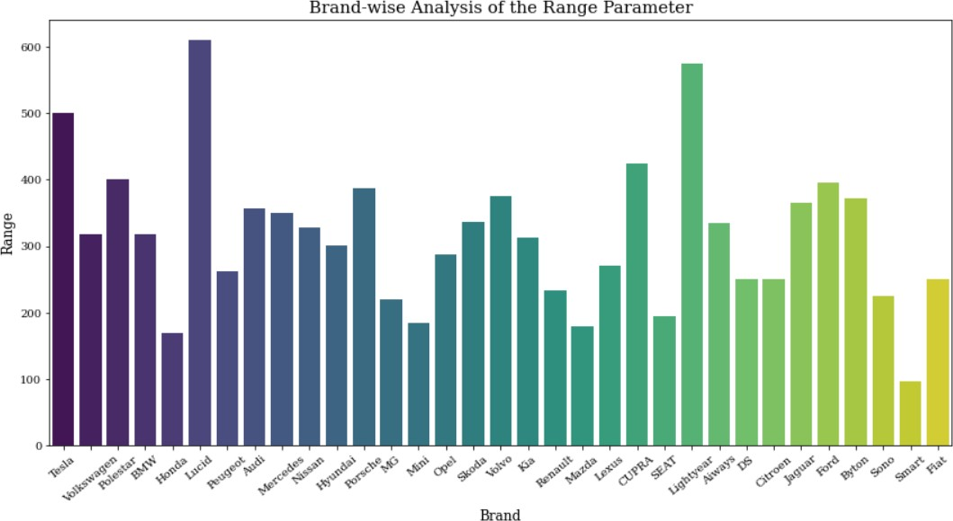

Correlation matrix for the features in one of the dataset used.

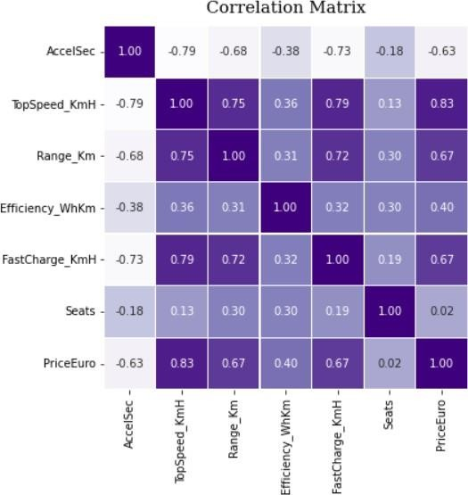

## Segment Extraction

K-Means Clustering is one of the most popular Unsupervised Machine Learning Algorithms Used for Solving Classification Problems. K Means segregates the unlabeled data into various groups, called clusters, based on having similar features, common patterns.

Suppose we have N number of Unlabeled Multivariate Datasets of various features like wateravailability, price, city etc. from our dataset. The technique to segregate Datasets into various groups, on the basis of having similar features and characteristics, is called Clustering. The groups being Formed are known as Clusters. Clustering is being used in Unsupervised Learning Algorithms in Machine Learning as it can segregate multivariate data into various groups, without any supervisor, on the basis of a common pattern hidden inside the datasets.

In the Elbow method, we are actually varying the number of clusters (K) from 1 – 10. For each value of K, we are calculating WCSS (Within-Cluster Sum of Square). WCSS is the sum of squared distance between each point and the centroid in a cluster. When we plot the WCSS with the K value, the plot looks like an Elbow.

As the number of clusters increases, the WCSS value will start to decrease. WCSS value is largest when K = 1. When we analyze the graph, we can see that the graph will rapidly change at a point and thus creating an elbow shape. From this point, the graph starts to move almost parallel to the X-axis. The K value corresponding to this point is the optimal K value or an optimal number of clusters.

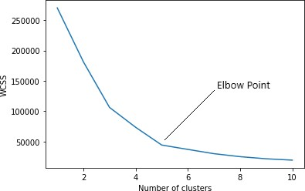

## Profiling Potential Segments

**Behavioral Segmentation:** Segmenting the market based on customer behavior aspects such as what price range customers usually buy in, what kind of specifications customers look for in their cars, etc.

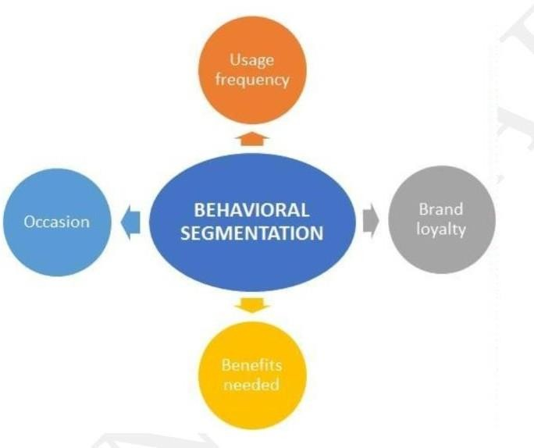

**Psychographic Segmentation:** Segmenting the market based on psychological parameters, such as the likes and dislikes of customers, whether they prefer comfort over speed of a vehicle, etc.

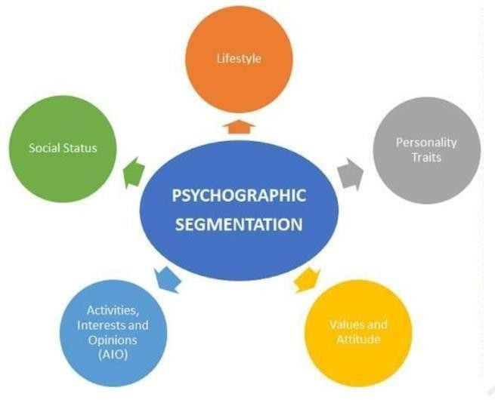

**Geographic Segmentation:** Segmenting the market based on geography. This mainly includes characteristics of the market based on the location.

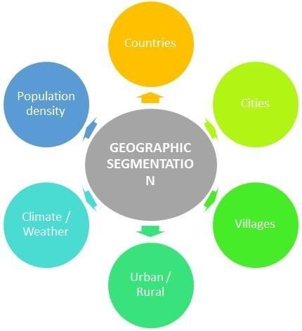

The major use of EVs in India is for daily commute.

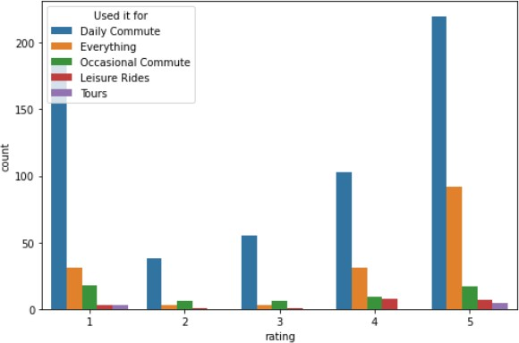

### Psychographic Factors

Comfort, Visual Appeal and Value for Money are other key psychological aspects that attract customers.

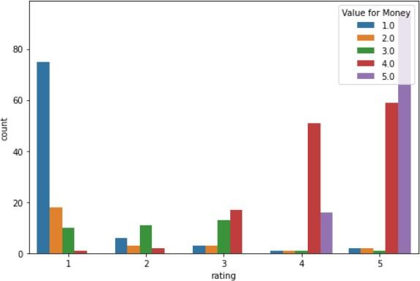

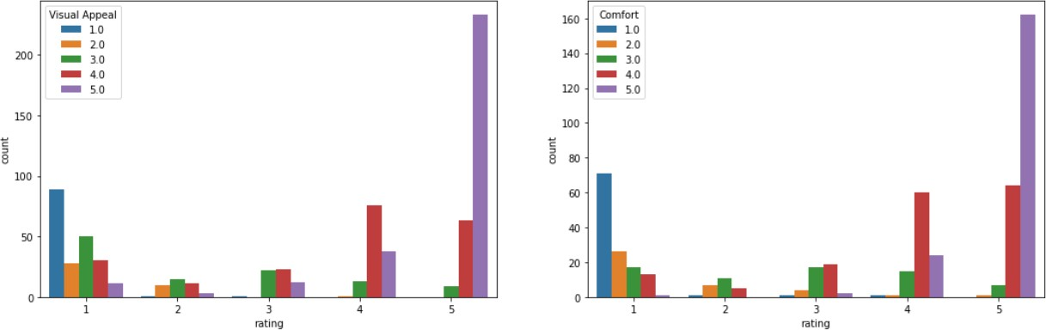

Major psychographic factors to consider – Value for Money and Comfort.

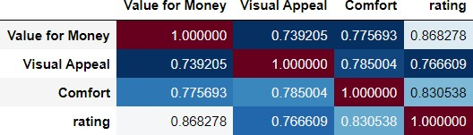

### Behavioral Factors

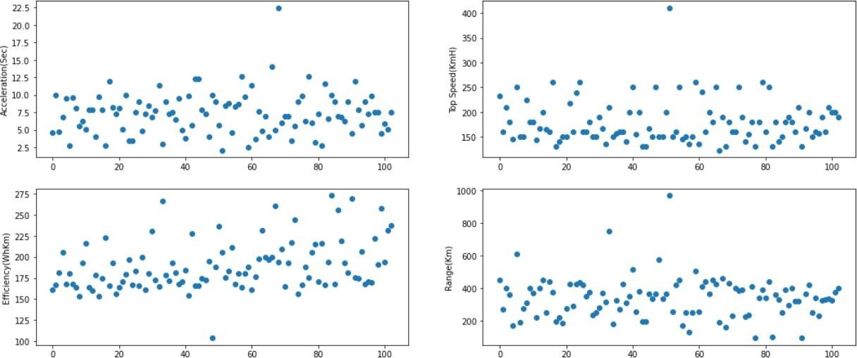

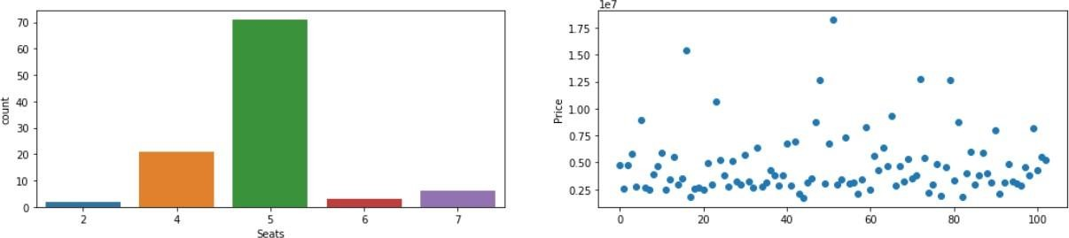

Inferring from the graphs, most of the EVs belong to the 5-seater category. An average price range of 20-30 Lakhs and an Efficiency-high vehicle would do well in the market. Acceleration seems to matter more than the top speed of the vehicle.

Major behavioral factors to consider – Price, Efficiency, Acceleration

### Geographic Factors

The following graph shows the number of sales of EVs in different states.

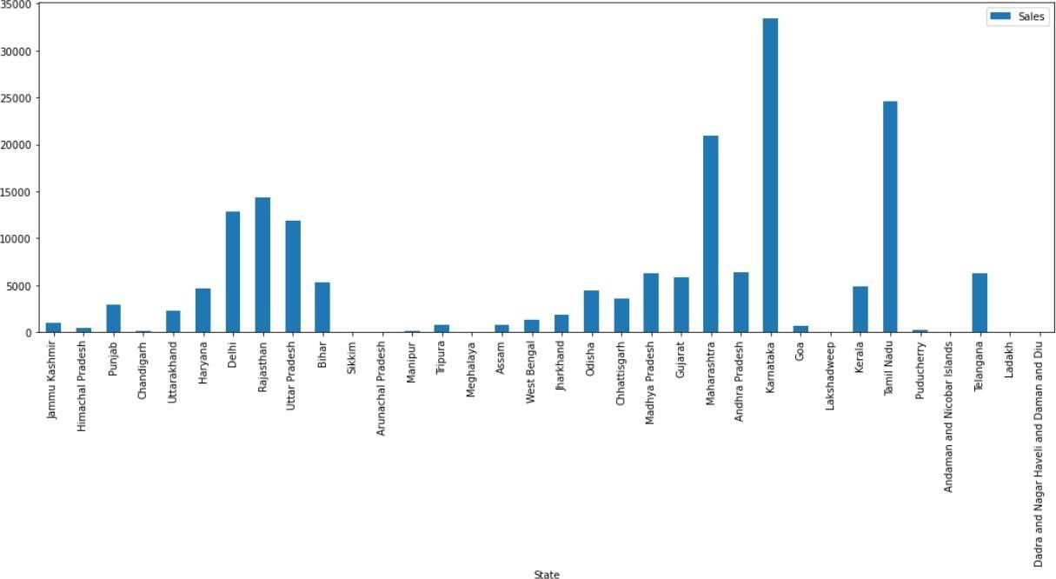

States like Maharashtra, Karnataka, Tamil Nadu and Rajasthan are good geographic locations to consider for an EV market.

## Target Segments

Based on the analysis, the target segment can be narrowed down to EVs having:

* **Psychographic factors** such as Comfort and Value for Money
* **Behavioral factors** such as good Acceleration and viable Price range
* **Geographic factors** such as States which are more market friendly

In conclusion, the target segment should comprise of EVs having **Acceleration** of 7.5-10 sec, High in **Comfort** and **Value for Money** ratings, have a **Price** range of 20-30 Lakhs, and be focused mainly on **States** such as Maharashtra, Karnataka, Tamil Nadu and Rajasthan.

## Customizing the market mix

The marketing mix helps enable the growth of the business in the automotive industry. A company’s marketing mix or 4Ps (Product, Place, Promotion, and Price) specify the approaches and strategies that address the target market, based on the details of the marketing plan. The company’s aim is to maximize sales and improve market presence. With a strong position in the market, However, strategic decision-makers must allow for flexibility in relevant strategies.

The automotive market has various opportunities for the growth, such as opportunities for products that integrate advanced computing technologies. However, the company faces threats in its business environment. Managers can use the SWOT Analysis to determine appropriate adjustments in the marketing mix or 4Ps to deal with these threats and opportunities.

## Product Mix

This aspect of the marketing mix pertains to the outputs of the business. Each product line represents a group of outputs or products. The set of all the product lines is called the product mix. the product mix shows limited business diversification. Nonetheless, the company offers a wide variety of products, such as different brands, types, and models of automobiles.

1. Automobiles
2. Automobile parts
3. Commercial vehicles
4. Financial services

## Prices and Pricing Strategies

The setting of price points and price ranges for the company’s products is the main concern in this aspect of the marketing mix. Pricing affects the perceived value of brands and products, and influences sales in price-sensitive markets. the pricing strategies for its automotive products are as follows:

1. Market-oriented pricing strategy
2. Premium pricing strategy

## Promotional Mix

Promotional activities are considered in this aspect of marketing mix of 4Ps. These activities are also known as marketing communications tactics. The combination of these tactics is called a promotional mix or marketing communications mix the following promotional activities are used, arranged according to significance in the automotive business:

1. Advertising (primary)
2. Direct marketing
3. Personal selling
4. Sales promotion
5. Public relations

## Place/Distribution

In this aspect of marketing mix or 4Ps, the virtual or physical locations of transactions are considered. Such locations are significant because they enable the company to reach target customers in specific markets, while also allowing customers to access information and products available from the automotive business. The following places are used in the distribution of products and services:

1. Official websites
2. Dealerships
3. Automotive shows and exhibits

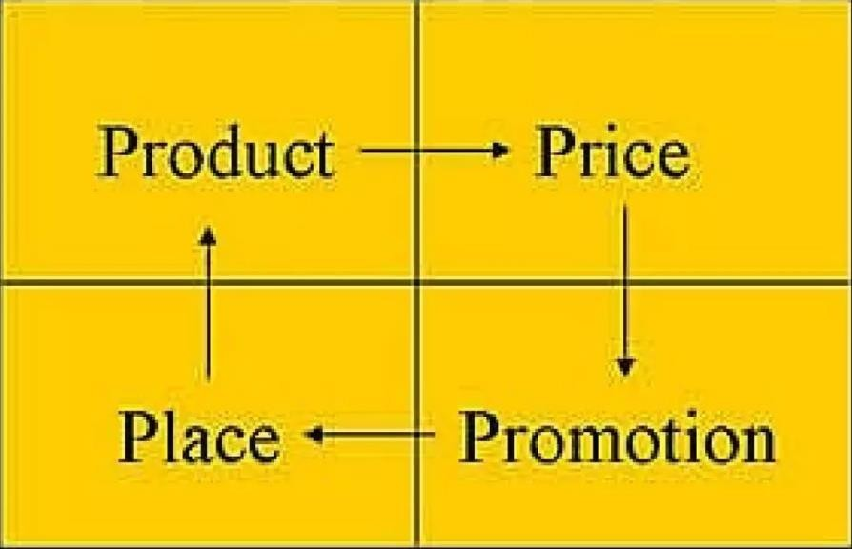

## Potential Sales in Early Market

Purchasing a vehicle is one of those life accomplishments that top nearly everyone’s bucket list. The majority of the customers have a family. For such folks there are a variety of reasons, including market and schooling. Whether you prefer a modernized urban loft or a sprawling suburban home with a white picket fence, most of us hope to find a vehicle that feels like it was made specifically for our family. Here is where our insights come in to assist such people to find a best vehicle at the best-fixed price according to the area and several other factors.

Some of the key points required to focus for the development of EV in India are:

1. Retrofitting conversion of Public Transport (Bus), Taxi and Three-Wheeler (Auto) to PHEV: This is one of the key requirements to move towards sustainable transportation. It will not only balance emissions but also reduce the load on infrastructure requirement.
2. Government Incentives: Another key factor for XEV market to lift up will be identification of strategic incentives for electric vehicles. This will increase adoption rate and decrease main element barrier of the price of electric vehicles to customers. The incentive can be subsidy scheme for electric vehicles bridging gap price between the conventional and electric vehicle in similar performance range. e.g., if the cost of internal combustion engine car is INR 5 lakh and that of the electric vehicle is INR 6.5 lakh, the government can intend to offer discount or subsidy of the differential cost. In addition, benefit of Discount on VAT//Discount on Registration/Discount on Toll Plaza to motivate sell of EV can be planned.
3. Charging Infrastructure: Charging infrastructure development will occur with the development of XEV market. However, motivation can be provided by developing grid-connected charging station with the moderate tariff, promotion to standalone renewable (solar/wind) charging station, add on facility at petrol pump and bus stops for charging and state transport charging stations and permitting the development of private renewable charging stations.
4. Electrical Propulsion System (EPS): Currently no Indian manufacturer provide electrical propulsion system (EPS) manufactured in India, even REVA has a tie-up with Italy for EPS.

Hence support and positive atmosphere build-up in manufacturers in one of the critical tasks. Development of clear policies for supporting the growth of supply, manufacturing, and recycling of propulsion system. Power electronics converter and motor technology development are feasible as technology base is available in India, however currently used cost-effective Li-ion technology of battery development is challenging task as the majority of lithium stock are available in China and USA. In addition, battery replacement/swapping can be one of the promising and viable options in India.

1. Development of Skilled Manpower: Consideration of safety and advanced technology involved, development of certified skilled technician and professionals is one of the requirements.
2. Awareness: Awareness on benefits of XEV and promotions of the government can play a significant role in development. It can be done with the help of extensive advertisement at airport/bus station/cinema halls/government offices/public places using banners/hoardings, use of print media-newspaper/magazines/periodicals, digital media/radio/e media-internet, TV shows, expert talks, providing micro-funding for projects/conferences in schools, colleges and industry, supplying R & D grants to research scholar/institute/industry. The promotional highlights for the consumer can be:
   1. Good for the environment/Lowers Emission: Electric vehicles emit lower levels of a

range of air pollutants, e.g. nitrogen oxides, particulate matter and greenhouse gases( e.g. carbon dioxide-CO2) than vehicles using conventional petrol and diesel engines.

* 1. Cheaper to run/Improve Fuel Economy: As electricity is cheaper than petrol or diesel, the running costs of EVs are less than conventional vehicles.
  2. Less Life Cycle Cost.
  3. Perfect for urban use: Reduced levels of pollution and noise make EVs ideal for inner city and urban use.
  4. Smooth acceleration and deceleration: EVs benefit from smooth gearless acceleration and deceleration, as a result of the characteristics of the electric motor.
  5. Quieter than conventional vehicles: EVs are also quieter than conventional vehicles. Battery operated cars operate in almost complete silence except noise from the tires.
  6. Proved Technology (a sharp rise in the market of XEV all over the world).

## Most Optimal Market Segment

There are many EV manufacturing companies in the country like Hero Electric, Tata Motors, Ather Energy, Ashok Leyland, Hyundai Kona Electric, etc. Tesla has also arrived; the demand will get higher & higher since it is automotive so the investments and policies and all that would be bigger but it will take some time to perfectly settle in India. The following are the key insights of the project:

* The electric vehicle industry has not done that much good due to the devastating hit of the Covid outbreak but it will take a huge jump in upcoming years.
* The use of EVs will be game-changing in terms of environment, air, noise pollution-free, postelectric, and much more.
* The company should plan to establish local operations in India either by partnering with a local company or by setting up its own manufacturing/ development unit, potentially combined with imports of specific components.
* The company would expect to further grow in India, underpinned by a growing commercial fleet market for two-wheelers and three-wheelers especially for last km delivery/urban freight services. The company must see opportunities across the supply chain in the battery, EV component and charging infrastructure segments including the machinery and equipment needed for establishing manufacturing plants, training and provision of skilled workforce etc.
* The company should start their business from Metro Cities in India and then after considerable business expand to other cities of the same state of the Metro Cities. This will help the company to expand easily as they will be having a prior knowledge of business from Metro Cities and Network of Supply chain will be easy for the company as the time goes in business.

In the conclusion, electric vehicles are the future hence - **“*Go Green Go Electric*”.**